**PRESS RELEASE – FOR DISTRIBUTION**

**APRIL 12, 2017 AT 6am EDT / 11am BST / 12pm CET / 1pm EET**

**Polar Announces Polar M460 GPS Bike Computer with Advanced Power Meter Compatibility and Smart Coaching**

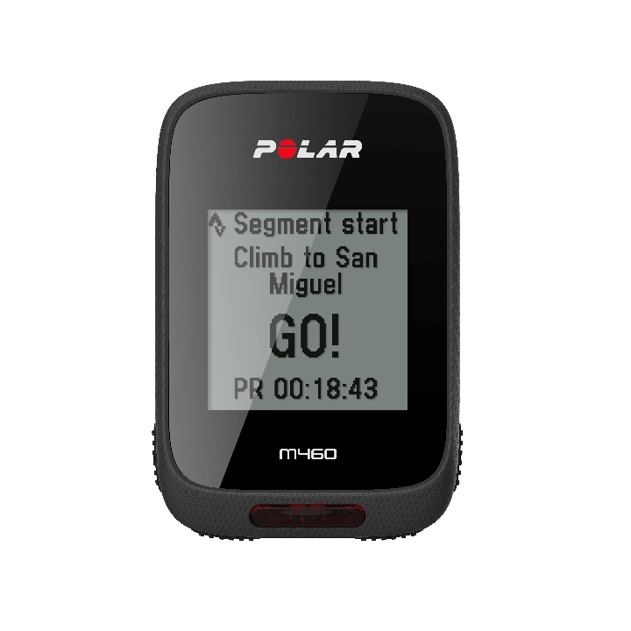 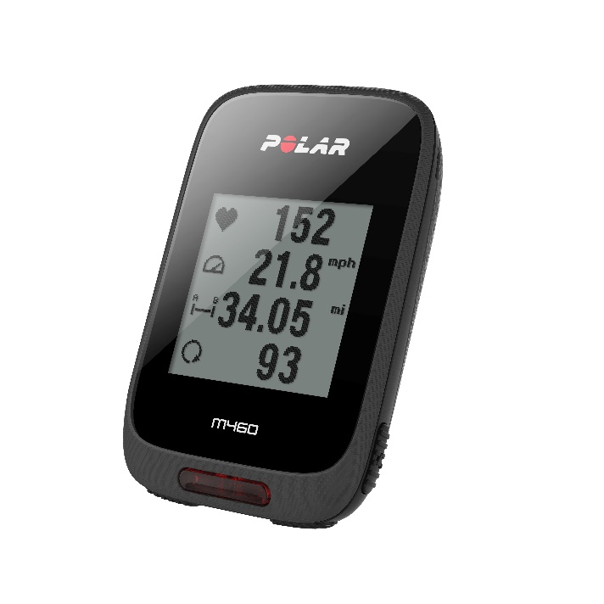

*Polar’s latest GPS bike computer features advanced power meter compatibility and power metrics for serious cyclists*

**KEMPELE, FINLAND – April 12, 2017 –** [Polar](http://www.polar.com/), the leader in wearable sports and fitness technology for 40 years, introduces the latest addition to its cycling portfolio, the [Polar M460](http://www.polar.com/en/products/sport/M460-gps-bike-computer). Featuring a sleek, all-black and fiber-like surface texture with improved button grip, the bike computer is equipped with integrated GPS, additional power meter compatibility, advanced power metrics and smart coaching, and Strava Live Segments, making it the ideal training tool for cyclists aiming to reach their goals. The Polar M460 will be available in April at [www.polar.com](http://www.polar.com) from $179.90/€179.90 and includes a two-month Strava Premium membership.

Learn more about the new Polar M460 [here](http://www.polar.com/en/products/sport/M460-gps-bike-computer).

“Polar’s experience working with professional athletes and coaches helps us develop the necessary technology to make Polar M460 a reliable tool for athletes during various stages of their training sessions,” said Marco Suvilaakso, Chief Strategy Officer of Polar. “Polar’s cycling products have become a staple for devoted cyclists who are passionate about their training and want to reach their goals.”

The versatile Polar M460 boasts reliable, integrated GPS and barometer-based inclinometer, compatibility with an extensive list of third party power meters and advanced cycling power metrics, such as Training Peaks’ Normalized Power®, Intensity Factor® and Training Stress Score®, to make training more efficient. Keeping cyclists connected, the Polar M460 also includes smart notifications for incoming calls, texts, calendar alerts and social media updates, as well as [Strava Live Segments](http://blog.strava.com/strava-live-segments-11890/), allowing cyclists to see real-time stats to help them reach peak performance, while bringing the excitement of the social network for athletes to each ride. Additional features include IPX7 rating water resistance, a battery life offering 16 hours of training and front LED light.



When paired with the new [Polar H10](https://www.polar.com/en/products/accessories/H10_heart_rate_sensor), athletes benefit from Polar’s industry leading heart rate technology, designed and tested for reliability, as well as the company’s proprietary [Smart Coaching](http://www.polar.com/en/smart_coaching) features via Polar Flow. These features include [Fitness Test](https://www.polar.com/us-en/smart_coaching/features/fitness_test), which enables athletes to gauge their current fitness levels and see progress along the way, [Training Load](https://www.polar.com/us-en/smart_coaching/features/training_load), which shows how a ride affects an athlete’s body, [Orthostatic Test](https://www.polar.com/us-en/smart_coaching/features/orthostatic_test), which shows how an athlete’s heart rate responds to training and factors such as stress and illness, and [Recovery Status](https://www.polar.com/us-en/smart_coaching/features/recovery_status), which helps athletes find the perfect balance between training and rest.

“Polar is no novice player in the cycling game, and we prove that with the introduction of Polar M460 to our cycling product portfolio,” said Tom Fowler, President of Polar U.S.A. “Cyclists rely on accurate data to not only track, but improve their performance, and Polar has used its industry leading technology, combined with passion for constantly improving cyclists’ performance, to develop an incredibly advanced bike computer. When a cyclist is equipped with data that is not only expansive and in-depth, but accurate, they are then equipped to set and achieve personal goals that encourage peak performance.”

Polar M460 is $179.90/€179.90 and available with the new Polar H10 for $229.90/€229.90 at [www.polar.com](https://www.polar.com/us-en) in April. To learn more about Polar, visit [www.polar.com](https://www.polar.com/us-en).

**About Polar:**

Polar is the innovator in heart rate monitoring, activity trackers and training computers. With 40 years of experience and a proud heritage in physiological and sports medical research, we cater to all levels of fitness by offering a comprehensive product range including cycling computers, wearable sports devices and activity trackers, training apps and online services. Our award-winning training computers are the number one choice among consumers worldwide, being sold through over 35,000 retailers globally. Headquartered in Finland, Polar is a privately held company that operates in more than 80 countries including U.S. headquarters in Lake Success, NY. For more information, please visit [polar.com](http://www.polar.com).

# # #

**Media Contact:**

Max Borges Agency for POLAR

P: 305-374-4404 ext. 171

[polar@maxborgesagency.com](mailto:polar@maxborgesagency.com)